




Where to begin with a non-fiction text

What are the main ideas, themes or characters that are being introduced or
developed?
How does the writer’s point of view come across (for/against, positively/negatively)?
How do particular choices of words/phrases/ or lines within the extract affect the reader?
How do the articles show the similarities and differences across time?
Why is the writer seeking to have this effect?
What other parts, or key pivotal moments of the text does it suggest? What do you imagine the rest of the text to include or explore?
When I read this, what do I think is important? How does it add to, reinforce or change how I think about the topic, themes or ideas that I have been studying?
Tips for understanding, analysing and evaluating non-fiction texts

Start by working out the writer’s viewpoint- are they writing in favour or opposing the topic? Or both? How do you know?

Is the time that the article was written significant?

How would you describe the tone of the article- formal, informal, comical, sarcastic, nostalgic- how do you know?

Consider how they want you to react and how this helps them to agree with them.

Select words that make you imagine certain ideas- do they make any comparisons to strengthen their argument?

With all this considered, to what extent do you agree with the writer’s ideas? How effectively have they put their opinion across?



As we progress through the Component 2 unit, consider your own confidence to use the skills that you will be assessed against within the final exam.

CAPTIVITY
In this extract Charles Dickens asks us to imagine being a prisoner spending their last night in a cell before execution.
We entered the first cell. It was a stone dungeon, eight feet long by six wide, with a bench at the upper end, under which were a common rug, a bible, and prayer-book. An iron candlestick was fixed into the wall at the side; and a small high window in the back admitted as much air and light as could struggle in between a double row of heavy, crossed iron bars. It contained no other furniture of any description.
Conceive the situation of a man, spending his last night on earth in this cell. Buoyed up with some vague and undefined hope of reprieve, he knew not why - indulging in some wild and visionary idea
of escaping, he knew not how - hour after hour of the three preceding days allowed him for preparation, has fled with a speed which no man living would deem possible, for none but this dying man can know. He has wearied his friends with entreaties, exhausted the attendants with importunities, neglected in his feverish restlessness the timely warnings of his spiritual consoler; and, now that the illusion is at last dispelled, now that eternity is before him and guilt behind, now that his fears of death amount almost to madness, and an overwhelming sense of his helpless, hopeless state rushes upon him, he is lost and stupefied, and has neither thoughts to turn to, nor power to call upon, the Almighty Being, from whom alone he can seek mercy and forgiveness, and before whom his repentance can alone avail. Hours have glided by, and still he sits upon the same stone bench with folded arms, heedless alike of the fast decreasing time before him, and the urgent entreaties of the good man at his side. The feeble light is wasting gradually, and the deathlike stillness of the street without, broken only by the rumbling of some passing vehicle which echoes mournfully through the empty yards, warns him that the night is waning fast away. The deep bell of St. Paul's strikes - one! He heard it; it has roused him. Seven hours left! He paces the narrow limits of his cell with rapid strides, cold drops of terror starting on his forehead, and every muscle of his frame quivering with agony. Seven hours!
He suffers himself to be led to his seat, mechanically takes the bible which is placed in his hand, and tries to read and listen. No: his thoughts will wander. The book is torn and soiled by use - and like the book he read his lessons in, at school, just forty years ago! He has never bestowed a thought upon it,perhaps, since he left it as a child: and yet the place, the time, the room - nay, the very boys he played with, crowd as vividly before him as if they were scenes of yesterday; and some forgotten phrase, some childish word, rings in his ears like the echo of one uttered but a minute since. The voice of the clergyman recalls him to himself. He is reading from the sacred book its solemn promises of pardon for repentance, and its awful denunciation of obdurate men. He falls upon his knees and clasps his hands to pray. Hush! what sound was that? He starts upon his feet. It cannot be two yet. Hark! Two quarters have struck; - the third - the fourth. It is! Six hours left. Tell him not of repentance! Six hours' repentance for eight times six years of guilt and sin! He buries his face in his hands and throws himself on the bench.

This article tells us about life on prison ships, focusing on some of the rules for inmates and some of the job roles of people working on the ships.
… to convicts who have passed two years of their sentence, and not misconducted themselves.In cases of convicts misbehaviour, mild and persuasive means of correction are first tried. If such fail, the punishments are reduction of allowance of provisions, confinement in a dark cell with no other food than bread and water, for not more than seven days; or by mulcting earnings; or moderate whipping, which, in any case, is not allowed to exceed twenty four stripes.
“The overseer or officer in command is required to make a minute in the occurrence-book of the name of the convict, the name of the complainant, the nature of the crime, and the punishment inflicted. No convict is allowed to go without an iron upon one or both legs; and those employed on board are locked up and clothed in the same manner as those employed in the yards. An overseer is required to be on the watch all night in the dormitories. Chaplains are appointed in connection with
the different vessels, who are required, besides reading prayers and preaching on the Sabbath and the holidays of the Established Church, to attend to the religious wants of the prisoners individually, to distribute …
***…according to their discretion the books or tracts provided for the use of the prisoners, and to take a general superintendence of the schools for their instruction. A surgeon is employed in connection with the vessels, who is required to attend to the health of the convicts, inspect their provisions
occasionally, and see that the wards are properly ventilated. The employments of the convicts consist of shipbuilding and painting, carrying timber for this purpose, in removing chain-moorings, in cleansing the rivers on which they are employed, and in different descriptions of hard labour, and a limited number in keeping the vessels clean, preparing the food of the convicts generally, and making and repairing their clothes. Their periods of labour are from eight to nine hours and a half hour daily,
according to the seasons of the year. “The total expense per man in the hulks in England is £18 12s. 11d. The average value of labour per man is estimated at £10 18s. 9d. making the average annual expense per man £7 14s. 2d. The total
cost per boy in the hulks is £13 5s 6½d. The value of the labour performed by the prisoners in the hulks of Bermuda is so great as to leave an estimated annual profit for each of £13 3s. 6d.”
Notes
1. The overseer would submit quarterly returns to the Home Office (HO). These sworn lists of convicts give particulars as to the ages, convictions and sentences, health & behaviour of prisoners on board the convict hulks (until 1861) and are recorded in files at The National
Archives in series HO 8.
2. It is worth noting that the date of this article (1846) is almost 40-years after the detention and transportation of James Butler and the other hulk refusers (1808). It is clear that by the mid nineteenth century prison hulks were seen as places of detention/punishment in their own right rather than as transitory holding places pending transportation. Although many prisoners did serve out their sentences on the hulks at the beginning of the century, it was always intended that they would only serve on the hulks for a limited time before being transported to the southern hemisphere.
http://www.nationalarchives.gov.
This source is from an article that describes a slave auction in America in 1859.
The Sale...
"The buyers, who were present to the number of about two hundred, clustered around the platform; while the Negroes, who were not likely to be immediately wanted, gathered into sad groups in the background to watch the progress of the selling in which they were so sorrowfully interested. The wind howled outside, and through the open side of the building the driving rain came pouring in; the bar down stairs ceased for a short time its brisk trade; the buyers lit fresh cigars, got ready their catalogues and pencils, and the first lot of human chattels are led upon the stand, not by a white man, but by a sleek mulatto, himself a slave, and who seems to regard the selling of his brethren, in which he so glibly assists, as a capital joke. It had been announced that the Negroes would be sold in "families," that is to say; a man would not be parted from his wife, or a mother from a very young
child. There is perhaps as much policy as humanity in this arrangement, for thereby many aged and unserviceable people are disposed of, who otherwise would not find a ready sale......The expression on the faces of all who stepped on the block was always the same, and told of more anguish than it is in the power of words to express. Blighted homes, crushed hopes and broken hearts was (sic) the sad story to be read in all the anxious faces. Some of them regarded the sale with perfect indifference, never making a motion save to turn from one side to the other at the word of the dapper Mr. Bryan, that all the crowd might have a fair view of their proportions, and then, when the sale was accomplished, stepping down from the block without caring to cast even a look at the buyer, who now held all their happiness in his hands. Others, again, strained their eyes with eager glances from one buyer to another as the bidding went on, trying with earnest attention to follow the rapid voice of the auctioneer. Sometimes, two persons only would be bidding for the same chattel, all the others having resigned the contest, and then the poor creature on the block, conceiving an instantaneous preference for one of the buyers over the other, would regard the rivalry with the intensest (sic) interest, the expression of his face changing with every bid, settling into a half smile of joy if the favorite buyer persevered unto the end and secured the property, and settling
down into a look of hopeless despair if the other won the victory...The auctioneer brought up Joshua's Molly and family. He announced that Molly insisted that she was lame in her left foot, and perversely would walk lame, although, for his part, he did not believe a word of it. He had caused her to be examined by an eminent physician in Savannah, which medical light had declared that Joshua's Molly was not lame,
but was only shamming. However, the gentlemen must judge for themselves and bid accordingly. So Molly was put through her paces, and compelled to trot up and down along the stage, to go up and down the steps, and to exercise her feet in various ways, but always with the same result, the left foot would be lame. She was finally sold for $695. [equivalent to approximately $15,300 in today's dollars]
http://www.eyewitnesstohistory.com/slaveauction.htm

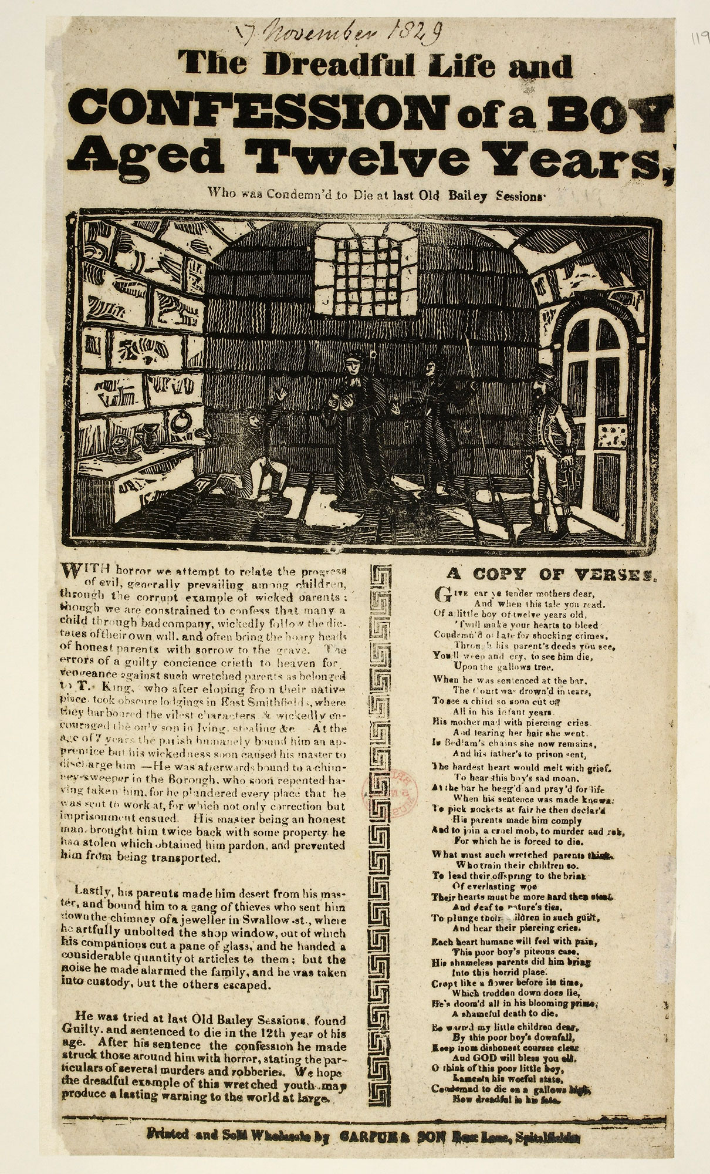
“It drives you mad if you’re locked up 23 hours a day. You start going mentally daft, walking up and down your cell half the day, lying down for the rest. I didn’t smoke much before; now I’m smoking my lungs out,” a 27-year-old remand prisoner from Glasgow says of the past three months, his first experience of prison. Accustomed to working at his family’s kebab restaurant, he says he has been asking to work since he arrived, to alleviate the boredom of life in the cell, but has been given no job.
The new governor, Ian Bickers, understands that Wandsworth will have to change dramatically if it is going to meet the government’s new vision for prisons. “What Michael Gove wants to do is to provide opportunities for men to learn, to rehabilitate themselves, to have a second chance. I don’t think you can do a mega amount of that here,” he says.
He is determined to improve things, but it is clearly a monumental and often thankless task. “Would I want to lock two people up in a room that’s 12 by 10 with a toilet in the corner every day, which was designed for one? Probably not actually. It is what you become used to. It is the system that we work with.”
Ministry of Justice figures in January show the prison is running at 166% over the “certified normal capacity”. Bickers says: “I don’t feel it is overcrowded, but the prison wasn’t built to house 1,600 people, so the workshop spaces aren’t there, the education spaces aren’t there, the physical healthcare provision isn’t where it should be. In an ideal world I wouldn’t want to double prisoners up, but sentencing policy has driven much more custody time for longer than we’ve seen at any other point in history and we haven’t had a prison-building plan that keeps pace with that.”

Extract from the Guardian, Inside Wandsworth prison: drug drones and demoralised staff
22nd February 2016

Prison Privaleges ReVamp (BBC News, 19th Feb 2016)
Male prisoners in England and Wales must work harder for privileges such as TVs in cells, the government has said.
Inmates will be made to wear a uniform during their first two weeks in jail and their access to private cash to call home will be restricted.
Satellite and cable TV channels, currently available in some private prisons, will be banned altogether.
The Prison Reform Trust said "getting rid of tellies" was not going to cut reconviction rates.
But Justice Secretary Chris Grayling said: "I want the arrival in prison for the first time to be an experience that is not one they'd want to repeat.
"That means an environment where they arrive [where] standards are pretty basic and then they start to gain extras by contributing... and if they won't do it, then they can't expect to start gaining those privileges."
There are currently three levels of privileges available to prisoners - basic, standard and enhanced. Currently all inmates must be placed initially on the middle tier when they enter prison.
This allows them to wear own clothes, have a TV in their cell and gives them more family visits, access to private cash and potential to earn more from prison jobs than those who are moved to basic level for poor behaviour.
However, from November, all prisoners will spend their first two weeks on a new "entry" level, which more closely resembles the basic standard currently in place.
Their behaviour will be reviewed after two weeks and they will either stay at the basic level or move up to the standard level.
Max Chambers, from the right-leaning Policy Exchange think tank, said the moves were "exactly what taxpayers would expect from our prison system" and would improve behaviour in jails.
Prison Reform Trust director Juliet Lyon said it was "perfectly reasonable" to remove subscription TV channels but there was no evidence to suggest that a "so-called tough approach" would improve rehabilitation.
"But, to be more effective, you have to focus on employment and skills training, on making sure people have safe housing to go to and that they have good contact with their family."

Could prisoner work plans take jobs from unemployed?
The government wants outside companies to more than double the number of jobs available in prison industries. Is this possible? And if it is, does it risk taking work away from law-abiding jobseekers?
The Justice Secretary Ken Clarke has won praise from all sides for his plan for "regime change" in English and Welsh prisons, making them into places of hard work and reform.
That is certainly not the reality for most prisoners now.
Just look at the statistics - there are 87,000 inmates and just 9,000 full-time jobs in prison industries.
Thousands more are employed in cleaning, cooking and other in-house occupations.
But for tens of thousands of prisoners, daily life consists of little more than sitting in a cell with two other convicts, smoking and watching daytime television.
Frances Crook of the Howard League for Penal Reform thinks this is a poor return for the taxpayer on a prison place costing £41,000 a year.
"There are 30,000 adult men serving long sentences and they spend years, sometimes decades, wearing pyjamas and pottering about as if it's an old people's home. It is completely purposeless," she says.
For thousands on shorter sentences, too, there is little activity to promote Mr Clarke's aim of reform - encouraging them to go straight.
More than half the prisoners released are re-convicted within a year and for some prisons, the figure is almost three-quarters.
So the government wants there to be a 40-hour working week for a growing number of inmates, with jobs that will teach them (perhaps for the first time) the habit of getting up in the morning and putting in a full day's work.
They may also learn skills that could make them more employable when they are released. Getting a job outside is linked to a lower chance of re-offending.
Ken Clarke puts it like this: "If you want less crime you've got to have fewer criminals, and that includes reforming a few of the criminals we have got inside by re-introducing them - or introducing them - to an honest day's work."

EXPLORATION and TRAVEL

THE LAST JOURNALS OF DAVID LIVINGSTONE, IN CENTRAL AFRICA,

FROM 1865 TO HIS DEATH. CONTINUED BY A NARRATIVE OF HIS LAST MOMENTS AND SUFFERINGS, OBTAINED FROM HIS FAITHFUL SERVANTS CHUMA AND SUSI, BY HORACE WALLER, F.R.G.S., RECTOR OF TWYWELL, NORTHAMPTON. IN TWO VOLUMES.—VOL. II. [1869–1873]
About 7th January, 1869.—Cannot walk: Pneumonia of right lung, and I cough all day and all night: sputa rust of iron and bloody: distressing weakness. Ideas flow through the mind with great rapidity and vividness, in groups of twos and threes: if I look at any piece of wood, the bark seems covered over with figures and faces of men, and they remain, though I look away and turn to the same spot again. I saw myself lying dead in the way to Ujiji, and all the letters I expected there useless. When I think of my children and friends, the lines ring through my head perpetually:
"I shall look into your faces,And listen to what you say,And be often very near youWhen you think I'm far away."
Mohamad Bogharib came up, and I have got a cupper, who cupped my chest.
8th and 9th January, 1869.—Mohamad Bogharib offered to carry me. I am so weak I can scarcely speak. We are in Marungu proper now—a pretty but steeply-undulating country. This is the first time in my life I have been carried in illness, but I cannot raise myself to the sitting posture. No food except a little gruel. Great distress in coughing all night long; feet swelled and sore. I am carried four hours each day on a kitanda or frame, like a cot; carried eight hours one day. Then sleep in a deep ravine. Next day six hours, over volcanic tufa; very rough. We seem near the brim of Tanganyika. Sixteen days of illness. May be 23rd of January; it is 5th of lunar month. Country very undulating; it is perpetually up and down. Soil red, and rich knolls of every size and form. Trees few. Erythrinas abound; so do elephants. Carried eight hours yesterday to a chief's village. Small sharp thorns hurt the men's feet, and so does the roughness of the ground. Though there is so much slope, water does not run quickly off Marungu. A compact mountain-range flanks the undulating country through which we passed, and may stop the water flowing. Mohamad Bogharib is very kind to me in my extreme weakness; but carriage is painful; head down and feet up alternates with feet down and head up; jolted up and down and sideways—changing shoulders involves a toss from one side to the other of the kitanda. The sun is vertical, blistering any part of the skin exposed, and I try to shelter my face and head as well as I can with a bunch of leaves, but it is dreadfully fatiguing in my weakness.

This letter, written by Charles Dickens in 1838, focuses on his journey to Yorkshire by train.
My dearest Kate,
I am afraid you will receive this later than I could wish, as the mail does not come through this place until two o'clock to-morrow morning. However, I have availed myself of the very first opportunity of writing, so the fault is that mail's, and not this.
Yesterday we were up again shortly after seven a.m., came on upon our journey by the Glasgow mail, which charged us the remarkably low sum of six pounds fare for two places inside. We had a very droll male companion until seven o'clock in the evening, and a most delicious lady's-maid for twenty miles, who implored us to keep a sharp look-out at the coach-windows, as she expected the carriage was coming to meet her and she was afraid of missing it. We had many delightful vauntings of the same kind; but in the end it is scarcely necessary to say that the coach did not come, but a very dirty girl did. As we came further north the mire grew deeper. About eight o'clock it began to fall heavily, and, as we crossed the wild heaths hereabout, there was no vestige of a track. The mail kept on well, however, and at eleven we reached a bare place with a house standing alone in the midst of a dreary moor, which the guard informed us was Greta Bridge. I was in a perfect agony of apprehension, for it was fearfully cold,
and there were no outward signs of anybody being up in the house. But to our great joy we discovered a comfortable room, with drawn curtains and a most blazing fire. In half an hour they gave us a smoking supper and a bottle of mulled port (in which we drank your health), and then we retired to a couple of capital bedrooms, in each of which there was a rousing fire halfway up the chimney. We have had for breakfast, toast, cakes, a Yorkshire pie, a piece of beef about the size and much the shape of my portmanteau, tea, coffee, ham, and eggs; and are now going to look about us. Having
finished our discoveries, we start in a postchaise for Barnard Castle, which is only four miles off, and there I deliver the letter given me by Mitton's friend. All the schools are round about that place, and a dozen old abbeys besides, which we shall visit by some means or other to-morrow. We shall reach York on Saturday I hope, and (God willing) I trust I shall be at home on Wednesday morning.
I wish you would call on Mrs. Bentley and thank her for the letter; you can tell her when I expect to be in York. A thousand loves and kisses to the darling boy, whom I see in my mind's eye crawling about the floor of this Yorkshire inn. Bless his heart, I would give two sovereigns for a kiss. Remember me too to Frederick, who I hope is attentive to you.
Is it not extraordinary that the same dreams which have constantly visited me since poor Mary died follow me everywhere? After all the change of scene and fatigue, I have dreamt of her ever since I left home, and no doubt shall till I return. I should be sorry to lose such visions, for they are very happy ones, if it be only the seeing her in one's sleep. I would fain believe, too, sometimes, that her spirit may have some influence over them, but their perpetual repetition is extraordinary.
Love to all friends.

Ever, my dear Kate,
Your affectionate Husband
http://opencorrespondence.org/letter/6

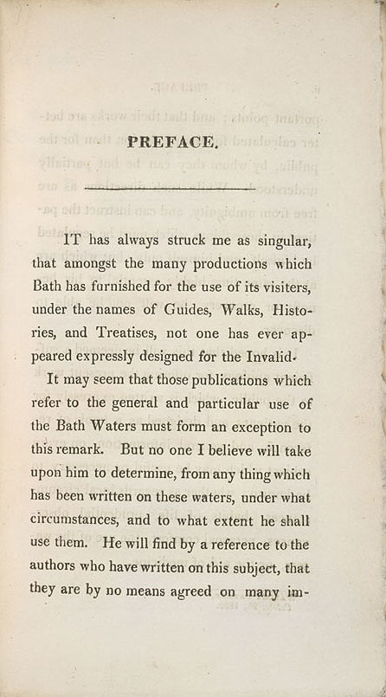

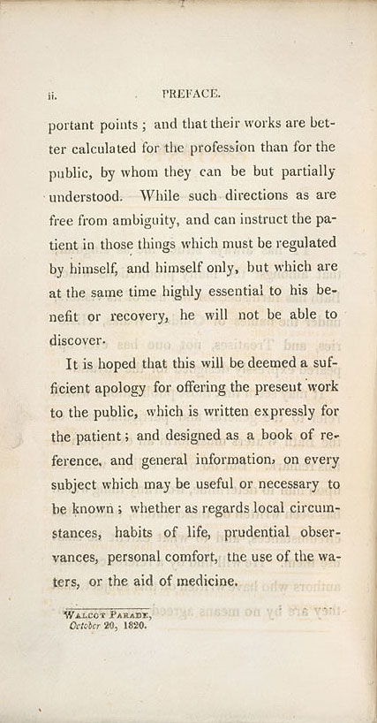

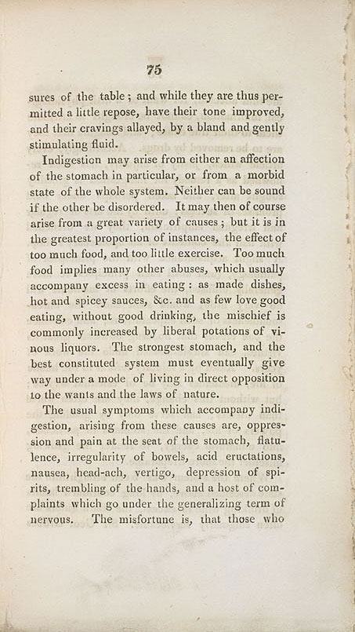

Taking the Bath waters
By Lydia Slater, Evening Standard Last updated at 14:07 01 July 2003

The River Avon at Bath
Who can ever be tired of Bath?' Jane Austen once had a heroine exclaim. How right she was: 200 years later, it's still a fun place to go for the weekend. It hasn't changed all that much since Austen's day.
While Bath has suffered both from the bombing of the Baedeker raids during the Second World War, and from some particularly unattractive and ill-considered reconstruction afterwards, the centre has remained largely unspoilt and she would still feel at home here, wandering the gracious curving terraces of butter-coloured stone.
Especially if she was staying at Paradise House. This beautiful 18th-century mansion calls itself a B&B, but it's a particularly luxurious one, set in a large and lovely garden overlooking the city, an easy ten-minute stroll away.
From the moment we were ushered into our bedroom, with its four-poster bed, oil paintings, toile de Jouy wallpaper and full-length windows giving on to a vista of wisteria and clematis, we started to relax.
It would have been delightful to order champagne and contemplate the sunny gardens. But time pressed: there is far too much to do in Bath to sit in your hotel room, however nice it may be.
Instead, in Austen's honour, we decided to follow a typical 18th-century itinerary. So, after a hearty breakfast, we headed straight to the Pump Room to ingest some of the healing spring water.
Bath is Britain's only hot-spring spa and, as such, has been a place of pilgrimage for the gouty for centuries.
Legend has it that, back in the mists of antiquity, a young prince, Bladud, suffered from leprosy and was forced to leave his father's court to herd equally leprous swine.
One day, the pigs plunged into a steaming swamp by the river, emerging completely healed. Bladud sensibly took the cure himself and went on to become king (and also, incidentally, the father of King Lear).
Given its miraculous qualities, it seems churlish to balk at paying 50p for a glass of this water, which emerges from the ground steaming hot and naturally fortified with a whole chemist's shop of minerals.
We were served by a man in Georgian dress whose skin suggested he hadn't been drinking as much of it as he should. And who could blame him? It tasted like saucepans boiled up with chalk.
I would have spat it out, had I not caught the reproving eye of Beau Nash, whose white-hatted portrait hangs in the Pump Room's antechamber. (Nash, gambler, dandy and Bath's Master of Ceremonies in the mid-18th century, is largely responsible for the flattering and entirely outdated reputation of the English for extreme politeness.) So I held my nose and swallowed. Thankfully, Sally Lunn's refreshment house, the oldest in Bath, is a mere skip away, where a muffin the size of my head eventually took the taste away.
You can't visit Bath without visiting the Baths, so get there early to avoid ravening tourist hordes.
Aquae Sulis, as the baths were known, were built by the Romans and are now surrounded by an extremely hi-tech (and expensive) museum, where handsets give you an ondemand guide to the different baths, and the coins, curses and monuments unearthed within.
Ditch the handset when you get to the atmospheric Great Bath, deep green and faintly steaming, and simply use your imagination to evoke centuries of hopeful and scrofulous bathers.
Sadly, you can't experience it for yourself: it's been 25 years since bathing here was allowed (in fact, signs around the Great Bath's perimeter warn, rather hysterically, that just touching the water can be dangerous).
I couldn't shake off the nagging feeling that earlier visitors to Bath had more fun than the nanny state will now allow.
Emerging from the Baths, I was delighted to be proved wrong. A hundred yards away, workmen were toiling on the Bath Spa Project, involving the restoration of two disused Georgian baths, which have been updated with a spectacular glass atrium.The plan is that it will open as a public spa at the end of July, offering visitors the chance to bathe once more in the natural hot springs.
By this stage, I could have done with a bit of healing, especially around the feet.
The unmissable activity for any Bath visitor is wandering the streets, gazing at the Palladian glories created by John Wood and son, Bath's developers, responsible for the city's most beautiful streets, the eye-popping Circus and the Royal Crescent, that almost made me oblivious to my developing blisters.
But there comes a time when one should abandon Georgian gentility and explore Bath's other side: the friendly, hippie, veggie, last-stop-before-Glastonbury atmosphere which makes this city so much more fun to spend time in than the uptight Cheltenham it resembles.
It was time, in short, for a pint. The Bell in Walcot Street has blues on the stereo, amiable barmen with eccentric hair and tie-dye shirts, and serves a delicious pint of the local Summer Lightning (with a single 30p cigarette if you're feeling naughty).
Perhaps things weren't necessarily nicer in Austen's day, I reflected, taking a refreshing gulp.This certainly beat the spa water into a cocked hat.

Astronaut Tim Peake in Bristol school hook-up (BBC News, 19th Feb 2016)
Students from a Bristol school have spoken to astronaut Tim Peake aboard the International Space Station.
Among the questions from pupils at Oasis Academy Brightstowe was one from 15-year-old Seema who wants to be the first female Afghan astronaut.
Major Peake told her it was a "wonderful idea and ambition" and that she should "follow her dreams"
The link up started at 14:20 GMT and lasted 10 minutes with the school using the special radio call sign GB1OAB.

How the contact was made
A computer programme tracks the ISS as it travels across the sky and this controls where the aerials are pointing and what frequency the VHF/UHF radio is on
As the students ask their questions the operator switches the transmitter on. At the end of the question he or she says 'over' and the transmitter is switched off.
The reply is received from space and played over loudspeakers in the hall.
There was a loud cheer from pupils, staff and parents as his voice crackled through the loudspeakers in the school hall for the first time and the live picture appeared on TV screens.
Sixteen-year-old Ashleigh wanted to know how many days' supplies the space station has on board and what would happen if a restocking mission could not take place?
Major Peake told him a few missions to restock had had problems but the space station had six-month's worth of reserves.
And nine-year-old Jacob asked why he had become an astronaut..
He replied he had been a pilot and it was the "pinnacle of his career" to "explore new frontiers".
The link-up was part of the Amateur Radio on the International Space Station project which aims to inspire students, to pursue interests and careers in science, technology, engineering and maths through an interest in amateur radio.

www.chrismacandless.com website biography
Chris was a good student with A average grades and he was also a good runner leading a team of cross country runners.But, he was very stubborn and strong willed. He would train his cross country team mates hard taking them on practise runs in places where it was easy to get lost. But he saw it as a challenge and saw running as a form of spiritual exercise. An example of his stubbornness was receiving an F for one subject because he refused to write an article in the particular way that the teacher had asked.

He graduated from High School in 1986 and shortly after took off on a solo adventure for the summer arriving back 2 days before he was due to start college. His room mate dropped out several weeks later but Chris went on to get excellent grades. He graduated from Emory University in 1990 but saw titles and honors as immaterial and irrelevant. Later he would say that university is a 20th century fad and not something to aspire to. Shortly after graduation, he gave the remaining money from his education fund to Oxfam. The cheque written by Chris on 15th May 1990, totalled $24000. He then left quietly from home to begin his adventures and assumed the name Alexander Supertramp of which he got from the book The Autobiography of a Super-Tramp by William H. Davies from 1908. When asked by someone where his family were, he would reply that he didn't have a family anymore. The challenge to himself was to travel with the least amount of belongings as possible and as little money as possible. He had no map and no agenda, just the will to travel.

His dream was the Alaskan adventure and he would tell this to those he met along the way. Some people he worked for on odd jobs would try to convince him to stay and some would insist on giving him supplies to help with the journey.He seldom accepted.He reached his final destination on April 28, 1992 in Fairbanks Alaska.Four months later he would perish from a combination of errors and his body was found in an abandoned old FairbanksCity Transit Bus numbered 142 which was located on the Stampede Trail.

He kept a journal along the way and took self portraits now and then. His final self portrait was a picture of him holding a farewell note in his left hand and waving with his right hand. He was but 30kg in weight and eventually died of starvation and possibly poisoning from fungus on some fruit he had eaten. His body was found by hunters 19 days after he died and later his parents would visit Bus 142 to leave a memorial.Jon Krakauer (A writer from Outside magazine) did an article on Chris in January 1993 and later wrote the book which in 2007 became the movie 'Into the Wild' by Sean Penn.

Chris' actions have caused many different debates on safety in the wild and what not to do and many have said thatwhat he did amounted to suicide. But, he has also had a lot of praise for his courage and spirit of adventure. Bus 142 has become somewhat of a tourist attraction, with many visiting every year and posting Youtube vidos and pictures on the internet.

Christopher McCandless Journal Entries for his Alaskan Adventure -

Day 69: Rained in, river looks impossible. Lonely, Scared. Day 74: Terminal man. Faster. Day 78: Missed wolf. Ate potato seeds and many berries coming. Day 94: Woodpecker. Fog. Extremely weak. Fault of potato seed. Much trouble just to stand up. Starving. Great jeopardy. Day 100: Death looms as serious threat, too weak to walk out, have literally become trapped in wild—no game. Day 104: Missed bear! Day 105: Five squirrel. Caribou. Day 107: Beautiful berries. Day 108-113: [Days were marked only with slashes.]

Megan Hine: the woman who helps keep Bear Grylls safe
She has been attacked by lions, chased through the jungle by an armed drug gang and can light a fire with a tampon. Meet the adventure expert who tests stunts and survival expeditions for TV
She has survived killer snakes, not washing for three months, gun-toting opium farmers and managed to keep dozens of clueless celebrities alive for outdoor endurance reality shows. Megan Hine is an expedition guide, one of Bear Grylls’ survival consultants and the woman you want to stick close to, come the resources wars: she can climb, abseil, knows which bugs to eat, and can start a fire with a tampon. And she’s warm and funny, too, so you wouldn’t mind if you were stuck on a desert island with her. As a bonus, she can catch fish with her bare hands.
We speak on the phone. She has just come back from a day of scouting locations in a Romanian forest for a TV show and is doing her best to avoid the bears. “It’s the time of year when they’re giving birth and you’ve got to be really careful about the caves.” You don’t need to be a survival expert to know you stay away from ferocious mothers and their cubs. She has seen some in the distance, but not up close, she says, adding “thankfully”.

(extract from the Guardian, February 2016).

HEALTHCARE

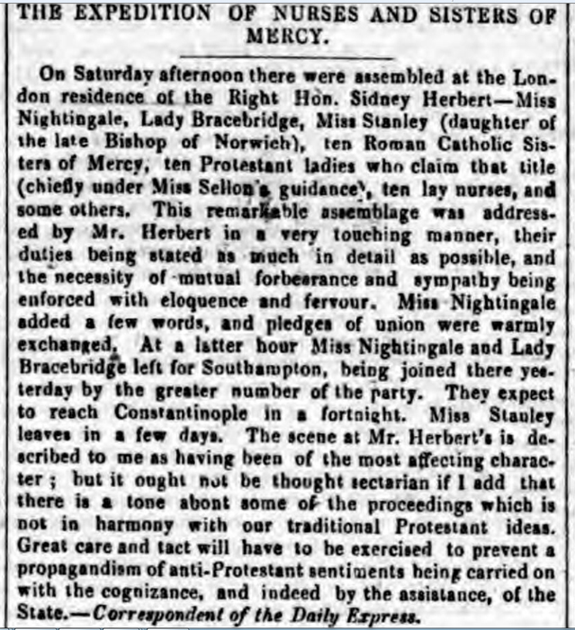

May 1856, Daily Express

The account of Florence Nightingale’s experiences in a hospital during the Crimean war.

A message came to me to prepare for 510 wounded on our side of the Hospital who were arriving from the dreadful affair of the 5th November from Balaklava, in which battle were 1763 wounded and 442 killed, besides 96 officers wounded and 38 killed. I always expected to end my Days as Hospital Matron, but I never expected to be Barrack Mistress. We had but half an hour’s notice before they began landing the wounded. Between one and 9 o’clock we had the mattresses stuffed, sewn up, laid down—alas! only upon matting on the floor—the men washed and put to bed, and all their wounds dressed. I wish I had time. I would write you a letter dear to a surgeon’s heart. I am as good as a Medical Times! But oh! you Gentlemen of England who sit at Home in all the well-earned satisfaction of your successful cases, can have little Idea from reading the newspapers of the Horror and Misery (in a Military Hospital) of operating upon these dying, exhausted men. A London Hospital is a Garden of Flowers to it. We have our Quarters in one Tower of the Barrack, and all this fresh influx has been laid down between us and the Main Guard, in two Corridors, with a line of Beds down each side, just room for one person to pass between, and four wards. Yet in the midst of this appalling Horror (we are steeped up to our necks in blood) there is good, and I can truly say, like St. Peter, “It is good for us to be here”—though I doubt whether if St. Peter had been here, he would have said so. As I went my night-rounds among the newly wounded that first night, there was not one murmur, not one groan, the strictest discipline—the most absolute silence and quiet prevailed—only the steps of the Sentry—and I heard one man say, “I was dreaming of my friends at Home,” and another said, “I was thinking of them.” These poor fellows bear pain and mutilation with an unshrinking heroism which is really superhuman, and die, or are cut up without a complaint. The wounded are now lying up to our very door, and we are landing 540 more from the Andes. I take rank in the Army as Brigadier General, because 40 British females, whom I have with me, are more difficult to manage than 4000 men. Let no lady come out here who is not used to fatigue and privation.… Every ten minutes an Orderly runs, and we have to go and cram lint into the wound till a Surgeon can be sent for, and stop the Bleeding as well as we can. In all our corridor, I think we have not an average of three Limbs per man. And there are two Ships more “loading” at the Crimea with wounded—(this is our Phraseology). Then come the operations, and a melancholy, not an encouraging List is this. They are all performed in the wards—no time to move them; one poor fellow exhausted with hæmorrhage, has his leg amputated as a last hope, and dies ten minutes after the Surgeon has left him. Almost before the breath has left his body it is sewn up in its blanket, and carried away and buried the same day. We have no room for Corpses in the Wards. The Surgeons pass on to the next, an excision of the shoulder-joint, beautifully performed and going on well. Ball lodged just in the head of the joint and fracture starred all round. The next poor fellow has two Stumps for arms, and the next has lost an arm and a leg. As for the Balls they go in where they like and come out where they like and do as much harm as they can in passing.

This is a poster that was put up in London in 1848, during the second outbreak of cholera.

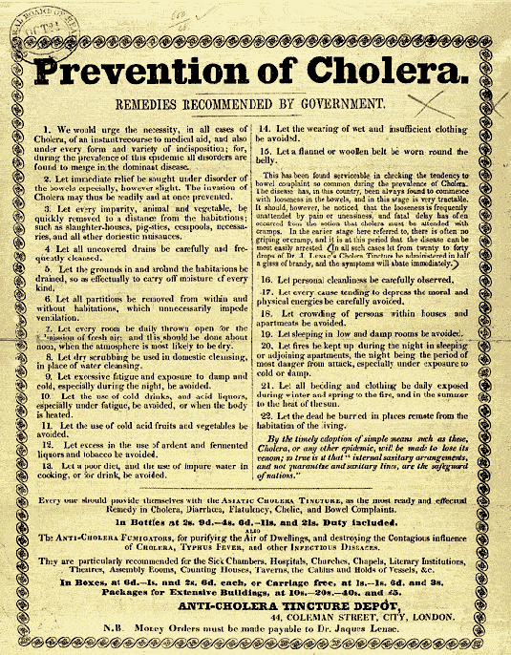

Swine flu patients on road to recovery (Leicester Mercury, Feb 17th 2016)
Three of the patients affected by swine flu following an outbreak of the infection on three wards at Leicester Royal Infirmary have been discharged from hospital.
Although 11 of the 14 patients who were being treated for cancer remain in hospital, more are likely to be discharged over the weekend.
A spokesman for Leicester's hospitals said the three haemotology wards at the infirmary remained closed.
Visiting is also still being restricted and people with cold and flu symptoms, such as a cough, runny nose or high temperature, have been asked to stay away from the hospital to avoid passing on their infections to patients.

However, the spokesman said there had been no new cases of the flu – the H1N1 strain of influenza, better known as swine flu.
Dr Philip Monk, consultant in communicable disease control with Public Health England in the East Midlands, said: "We will continue to monitor the situation.
"The quick action of the doctors and nurses at Leicester's hospitals I am sure made the difference in controlling the spread of this flu.
"It is what we regard as normal seasonal flu and it is not behaving in the terrible way that it did in 2009.
"Flu is flu and some people can be quite poorly."
Health officials are still urging people to make sure they get a flu jab – which takes about 10 days to effectively provide protection.
Latest figures from Public Health England (PHE) showed that nationally just over 41 per cent of pregnant woman have had the jab, plus one-third of children aged two and three and just under 29 per cent of four-year-olds.
The highest uptake – 69.8 per cent – was in the over-65 age group, with just over 43 per cent of people under 65 but with long-term health conditions having had the vaccination.
The annual seasonal flu vaccination now covers the H1N1 strain of the infection.
A PHE spokesman said: "The virus samples we have examined show the circulating strains of flu are a good match for this season's vaccine, at this stage.
"Flu is dynamic and things can change."

Nurses being placed in 'intolerable situations 5th October 2015 Channel 4
Nurses are being made to work in "intolerable situations", with many considering leaving the profession, according to a poll.
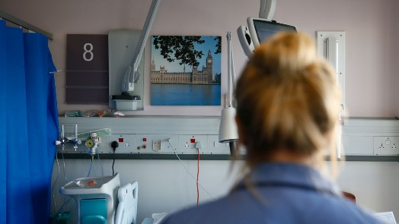
The Royal College of Nursing (RCN) surveyed more than 4,000 nurses found many felt undervalued, with too many patients to care for alongside too much paperwork.
Over half (56 per cent) claimed too much time was spent on non-nursing duties, with 59% too busy to provide the level of care they would like to.
43 per cent have seen an increase in the number of patients they are being asked to care for, while 42% of those working in the NHS said there had been recruitment freezes.More than a third (34 per cent) feel bullying and harassment is a problem within their workplace whilst 82 per cent have worked when not well enough to do so. Fewer than half (45 per cent) would recommend nursing as a career.
Josie Irwin, head of employment relations at the RCN, said: "Nursing staff are being placed in intolerable situations, working themselves sick and still not feeling they have been able to deliver the care they would like.
"Many nurses skip every break, work late after every shift, do their paperwork in their own time, and the pressure just increases.Many are coming in to work despite being unwell, often due to work-related stress. This is no good for nurses, but we know it will have an effect on patients too."
'Too much paperwork'
Of all those surveyed, 29% of nurses said they did not feel nursing would offer them a secure job in the future.Almost a third (31 per cent) were in the process of seeking a new job, with almost a quarter looking to leave the healthcare profession completely.53% said they worked extra hours to earn money to pay for bills and other living expenses and 32% have worked nights or evening shifts for the same reason.
One nurse told the RCN: "I have to work late most shifts to ensure workload is complete. Too much paperwork and not enough patient care."
Another stated: "The ward is intense and busy. We are running ourselves into the ground, not taking breaks and leaving an hour after shifts end to get all our work done. We should get paid a lot more for this amount of pressure."
The ward is intense and busy. We are running ourselves into the ground
Ms Irwin said: "Employers, the NHS and the Government need to work together to ensure that there are enough nurses, with the right level of skills, where they are needed.
"There needs to be a recognition that care is a part of all our futures, and we should value it, invest in it and train enough people to deliver it well."

EDUCATION AND CHILD LABOUR

3,000 children enslaved in Britain after being trafficked from Vietnam
Like many Vietnamese children, Hien was brought to Britain for a life of modern slavery. He ended up in prison on cannabis offences. We report on the gangs expanding across the UK and efforts to help their victims
Hien was 10 when he arrived in Britain. He did not know where he was or where he had been. He knew only that he was here to work. Since he emerged from the back of a lorry after crossing from Calais seven years ago, his experience has been one of exploitation and misery. He has been a domestic slave, been trafficked into cannabis factories, been abused and beaten and was eventually prosecuted and sent to prison. It has been a life of terror, isolation and pain.
Hien’s story is not unique. He is one of an estimated 3,000 Vietnamese children in forced labour in the UK, used for financial gain by criminal gangs running cannabis factories, nail bars, garment factories, brothels and private homes. Charged up to £25,000 for their passage to the UK, these children collectively owe their traffickers almost £75m.
While there is growing awareness of the use of trafficked Vietnamese people in the booming domestic cannabis trade, child trafficking experts are now warning that the British authorities are unable to keep up with the speed at which UK-based Vietnamese gangs are recruiting and exploiting children for use in other criminal enterprises such as gun-smuggling, crystal meth production and prostitution rings.
“By our calculations there are around 3,000 Vietnamese children in the UK who are being used for profit by criminal gangs,” says Philip Ishola, former head of the UK’s Counter Human Trafficking Bureau.
“The police and the authorities are now aware that trafficked children are being forced to work in cannabis farms but this is really only the tip of the iceberg. Often the same child will be exploited not just in a cannabis farm but also in myriad different ways. This is happening right under our noses and not enough is being done to stop it.”
Police admit that they are struggling with the speed at which Vietnamese criminal gangs are diversifying and expanding their activities across the England and into Scotland and Northern Ireland. “Right now we are just fighting in the trenches, fighting in the nail bars,” said detective inspector Steven Cartwright, who heads Police Scotland’s human trafficking unit. “It is vital that we that we understand new methods being deployed by the gangs because we need to stop demand at one end or limit their ability to make money at the other.”

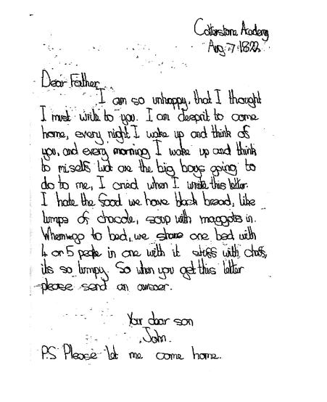

This extract from a parliamentary speech given by Lord Ashley (1768-1851) reflects on a report about the practice of sending children living in poverty to ‘ragged schools’.
The Report then goes on to say— The bulk of the scholars appear to be children of parents who can send their children to paying schools, and would do so were there no ragged schools. How any person who has visited the dens of poverty which exist in our large cities, and who has gone over those schools as I have done, day by day and hour by hour, could make such a statement as that I cannot understand. So far as Plymouth is concerned, at all events, its accuracy is, in the letters which I have received from that town, most solemnly denied. Where did those children go, I would ask, who now are received into the ragged schools before those institutions were established? Have we not seen them wandering about the Metropolis, forlorn and forsaken, with nobody to care for them either in body or soul? Did they find a refuge in the National or in the British schools? No such thing. They would not be received into them. We know very well that if these poor, shivering, naked creatures were admitted in the higher class of schools the only result would be that what I may call the "respectable" children would be withdrawn from them by their parents lest they might by communicating with the others incur disease, or be imbued with some moral taint. The Report then says that the promoters of ragged schools might better effect their object by supplying the children with clothes, and especially shoes, necessary to enable them to attend the ordinary day schools. If the Commissioners had known anything of the state of society among the parents of these children they would never have given such counsel. In the twinkling of an eye every
particle of clothing supplied to the children would go to the pawnbrokers and be converted into money, to be spent in many instances at the ginshop; and the recommendation that the children should be supplied with shoes, which they would not keep, instead of education, which they do keep, certainly exhibited extreme ignorance of the habits of the class in question.
But the Report proceeds as follows: — The only efficient mode of reforming such children is to separate them from their families, and to subject them to the strict discipline of the industrial schools. Now where, I should like to know, are the funds to come from to enable those children to be sent to industrial schools? This, when you have to deal with some 25,000 children, would be rather a grave undertaking. Where are industrial schools to be found capable of receiving so large a class?
Besides, I cannot conceive anything more mischievous than the wholesale exoneration on the part of parents from the discharge of their duties towards their children which you would by this means produce. One great advantage of the ragged school system is that through the children the managers of the society are 1917 able to get their parents. I could bring hundreds of teachers and persons conversant with the subject to bear testimony to the deep, lasting, and vital influence brought to bear
on degraded and besotted fathers and mothers, simply and solely through the agency of their children returned home from these schools, teaching, as it were, a new mode of life, and causing them to be ashamed of the course which they were pursuing.
http://hansard.millbanksystems.com/lords/1861/may/13/ragged-schools-motion-for

Foreword from the Sutton Report: what makes good teaching? 2015

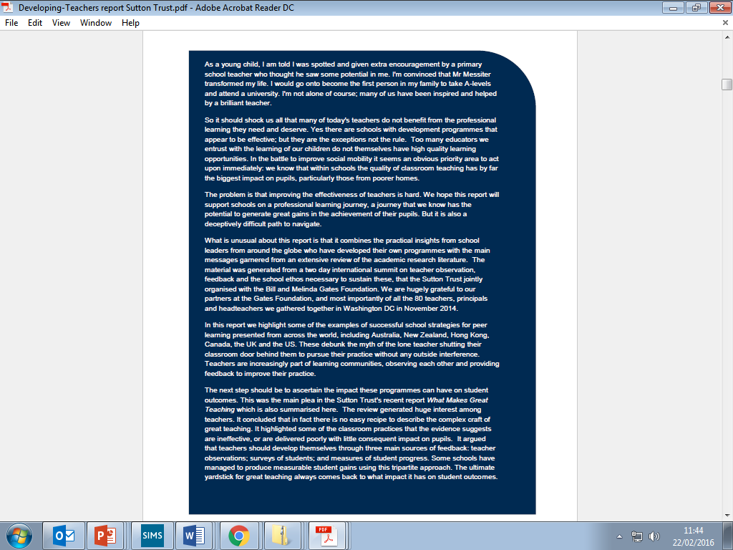

The 10 pros and cons all students should consider when thinking of studying abroad
Do the advantages outweigh the disadvantages? Have a look at our helpful list to find out
- Esther Nassaris Thursday 4 February 2016
It’s that time of year again: exams are over and it’s the perfect opportunity to use this fleeting piece of freedom to polish up your study abroad application.
But, perhaps, you’re still trying to decide whether it’s even in your best interest to study abroad for a year or not. You’ve heard stories about all the mad adventures friends and siblings have had, but you’re just not sure it’s for you. Well, here’s a handy list of pros and cons to help guide you towards a decision that best suits your interests:
PROS
1) Culture
Living in a new country will allow you to experience a completely different way of living. You can try exotic foods, listen to music you’ve never heard before, and learn about traditions specific to different countries. The things you learn will stick with you through life, ensuring you’re a much more knowledgeable and open person than you were at the start of the year.
2) New friends
Studying at a new university means meeting lots of new people and the opportunity to make new friends. Because this will be a unique experience, you’re more likely to appreciate the friends you make. The bonds you make will be lifelong, which will be incredibly useful for when you finish uni and want to travel. Need a place to stay during travelling? Well, now you have friends who live in those places.
3) Learn a new language
What better way to learn a new language than to be immersed in it completely? The best way to practice is to talk to native speakers - and you’ll have no shortage of those if you study abroad. Speaking multiple languages is always a good way to impress people, whether that’s on your LinkedIn or your Tinder profile.
4) Another travelling base
Not only will you be able to travel around your new home, but you will be closer to places that always seemed like a distant dream. It’s much easier to take a road trip around the states when you’re already in America. Or to visit New Zealand if you’re studying in Australia. Suddenly, there’s an entire world of opportunities next door and you have an entire year to take advantage.

5) Holidays
Ever noticed how the magic of Christmas has all but slipped away? How New Year tends to be an over-hyped disappointment? Feel like you’ve lived through these holidays enough for them to be just another day? Well, now you can bring back the magic by celebrating entirely new holidays. Dance at Cinco de Mayo, or watch the fireworks on the Fourth of July, and allow yourself to find the joy in festivities again.
CONS
1) Homesickness
You may be used to being away from your family while you’re at uni, but being in a different country is a whole other ball game. Not being able to pop home for visits during a quiet weekend or spend the holidays being pampered by your parents can definitely affect you if you’re not ready to take this step. However, with video-calling sites and apps, like Skype and FaceTime, homesickness is a lot more manageable today.
2) Lonely
It can be a very isolating experience if you don’t settle in well and make friends. It’s much more important to be able to put yourself out there and make more of an effort to join groups, attend socials, and initiate conversation, as you won’t already have a group of friends. If you’re not ready to be this outgoing, then studying abroad probably isn’t for you just yet.

MENTAL HEALTH
Fanny Fern (1811-1872) was a famous journalist. In this extract she recounts her visit to an American lunatic asylum.
My verdict after visiting a Lunatic Asylum is, [...] what an immense improvement has modern humanity effected in the treatment of these unfortunates! What an advance upon the diabolical cruelty of blows, and stripes, and iron cages, and nothing to do, and no room to do it in! Now, we have the elegant, spacious, well-ventilated and attractive building, surrounded with scenes of natural grandeur and beauty [...] One draws a long breath of relief to see them, under the eye of a watchful
superintendent, raking hay in the sweet, fresh meadows, or walking about in a beautiful garden [...]How affecting, too, is the child-like confidence with which they approach a perfect stranger, to tell the sorrow that is eating their lives away! “Poor Laura’s dead!” said one of them to me, in mournful tones. “Poor Laura’s dead!” she repeated, without awaiting an answer, looking sorrowfully in my face.
Another sat at the window of a handsome room, watching with a smiling countenance the gravel-walk that led to the building. As I entered, she said, “I don’t know when he will come; if it is not this winter, it will be next summer; he said he would come and take me away, and I am going to sit here and wait for him;” and she turned again to the window and looked far off into the bright sunshine, and folded
her hands in her lap in cheerful expectancy. As the key was turned in one of the wards a woman rushed to the door, and said fiercely to the doctor, “Let me out, I say!” He calmly barred the entrance with his arm, and laying one hand
soothingly on her shoulder, replied, “By and by-wait a little-won’t you?” Her countenance grew placid; and she replied, coaxingly, “Well, let me have one little peep out there then.” – “Yes,” said he, “you may go so far,” pointing to a designated limit, but not accompanying her. She walked out delightedly, took a survey of the hall, and promptly returning, said, “I wanted my father, but I see he is not there.”
It seemed so humane to satisfy the poor creature, even though one know she might be a prey so some other fantasy the next minute.
It is a very curious sight, these lunatics – men and women, preparing food in the perfectly-arranged kitchen. One’s first thought, to be sure, is some possibly noxious ingredient that might be cunningly mixed in the viands; but further observation showed the impossibility of this under the rigid surveillance exercised. As to the pies, and meats, and vegetables, in process of preparation, they looked sufficiently tempting to those who had earned a good appetite like ourselves, by a walk across
the fields. The poor French man was sane as a cook; his monomania was far out of his profession; it was poetry, and his epic had turned his brain. Some lunatic-women who were employed in the laundry, eyed me as I stood watching them, and, glancing at the embroidery on the hem of my skirt, a little the worse for the wet and dust of the road, exclaimed, “Oh, fie! A soiled skirt!” In fact, I almost began to doubt whether our guide was not humbugging us as to the real state of these people’s
intellects; particularly as some of them employed in the grounds, as we went out, took off their hats, and smiled and bowed to us in the most approved manner.
http://www.nathanville.org.uk/web-albums/burgess/scrapbook/health/pages/Victorian-Lunatic-Asylum_jpg.htm

23.02.16

Mindfulness therapy could save NHS money and reduce staff stress
Mindfulness practice for both patients and staff could save the NHS money and reduce staff stress, according to the first government report to consider mindfulness as a matter of public policy.
At the Salford launch of the Mindful Nation UK report, Jamie Bristow, director of the Mindfulness Initiative, said mindfulness-based cognitive therapy (MBCT) for people with depression and chronic pain could save the NHS £15 for every £1 spent.
The report says that a meta-analysis of six trials found that MBCT, which teaches patients to pay attention to what’s happening in the present moment in the mind, body and external environment with an attitude of curiosity and kindness, reduced the risk of relapse for people with depression by 43%. Depression is estimated to cost the country £9.19bn a year in lost earnings, and is forecast to cost the NHS £2.96bn in the next decade.
A review of 114 studies also found consistent evidence that MBCT improves the mental health and wellbeing of patients with conditions including cancer, lower back pain, fibromyalgia, arthritis and HIV.
Bristow said that mindfulness therapy is underutilised in the NHS at the moment, with 72% of GPs saying they wanted to refer patients to it but only one in five knowing how.
At the launch, Dr Peter Morgan, clinical psychologist at the Pennine Care NHS Foundation Trust and NHS Mindfulness Teacher Network, warned “it’s kind of countercultural at the moment to come in and be looking more broadly at wellbeing” in the NHS.
He also said that practicing mindfulness could benefit NHS staff, 39% of whom were made unwell by stress in 2014-15.
“We have to change this idea that seeking healthcare as NHS staff is somehow weak and we should just carry on and keep going,” he said.
Bristow also warned that the increased devolution of health and education services makes promoting mindfulness therapy harder, because providers have to approach individual organisations and compete against larger bodies such as pharmaceutical companies.
NHE will have more coverage of the Mindful Nation UK report online and in the Mar/Apr edition of the magazine.

The Five Year Forward View for Mental Health, February 2016
MENTAL HEALTH “The NHS needs a far more proactive and preventative approach to reduce the long term impact for people experiencing mental health problems and for their families, and to reduce costs for the NHS and emergency services”. Mental health problems are widespread, at times disabling, yet often hidden. People who would go to their GP with chest pains will suffer depression or anxiety in silence. One in four adults experiences at least one diagnosable mental health problem in any given year. People in all walks of life can be affected and at any point in their lives, including new mothers, children, teenagers, adults and older people. Mental health problems represent the largest single cause of disability in the UK. The cost to the economy is estimated at £105 billion a year – roughly the cost of the entire NHS. POLICY CONTEXT There has been a transformation in mental health over the last 50 years. Advances in care, the development of anti-psychotic and mood stabilising drugs, and greater emphasis on human rights led to the growth of community based mental health services. In the 1990s, the Care Programme Approach was developed to provide more intensive support to people with severe and enduring mental illness. There was a new emphasis on promoting public mental health and developing services for children and homeless people. In 1999, the National Service Framework for Mental Health was launched to establish a comprehensive evidence based service. This was followed by the NHS Plan in 2000 which set targets and provided funding to make the Framework a reality. A National Service Framework for Children, Young People and Maternity Services was then launched in 2004. In 2011, the Coalition government published a mental health strategy setting six objectives, including improvement in the outcomes, physical health and experience of care of people with mental health problems, and a reduction in avoidable harm and stigma. The strategy was widely welcomed. However, despite these initiatives, challenges with system wide implementation coupled with an increase in people using mental health services has led to inadequate provision and worsening outcomes in recent years, including a rise in the number of people taking their own lives. 5 MENTAL HEALTH TASKFORCE STRATEGY Yet, over the last five years, public attitudes towards mental health have improved, in part due to the Time to Change campaign. In turn, this increased awareness has heightened understanding of an urgent need to act on improving the experiences of people with mental health problems, both within and beyond the NHS. There is now a need to re-energise and improve mental health care across the NHS to meet increased demand and improve outcomes. In this context, NHS England and the Department of Health published Future in Mind in 2015, which articulated a clear consensus about the way in which we can make it easier for children and young people to access high quality mental health care when they need it. This strategy builds on these strong foundations. Mental health has not had the priority awarded to physical health, has been short of qualified staff and has been deprived of funds. We must provide equal status to mental and physical health, equal status to mental health staff and equal funding for mental health services as part of a triple approach to improve mental health care – a fresh mindset for mental health within the NHS and beyond.

Olly Alexander: 'You start to think you're alone and crazy but help is out there'
Years & Years singer speaks about facing mental ill health, reactions from fans and his anger at cuts in mental health services
Battling the mental health stigma needs courage, and Years & Years singer Olly Alexander has enough of it. By sharing details of his own battle against mental health, Olly has endeared himself to his fans and campaigners.
Olly has openly spoken about his battle with mental health problems recently. He described night terrors involving “really scary visions and dreams, so [he] wouldn’t want to sleep.” And he also admitted to eventually going in for counseling and cognitive behavioral therapy.
His openness has been a lifeline to troubled young people, according to fans and campaigners. Irrespective of whether the Years & Years singers win any of the four Brit awards for which they have been nominated, their presence will be cause enough for celebration, reports The Guardian.
The response to Olly’s openness has been astounding, prompting many of his fans to share their own experiences, both online and in person to the band.
An overwhelmed Olly said, “It shows that people really want to talk about these issues. Fans tweet me or message me on Instagram, and the reality of a lot of their lives is that they are dealing with mental health issues – I see it all the time. When I meet fans – after shows, or wherever – they sometimes tell me their life stories. There are so many young people struggling with anxiety, depression and mental health issues.”
Olly’s revelations have come at a time when the UK is facing the serious issue of increasing mental health problems among young people. Many celebrities have come out to campaign for a more proactive government approach to resolve the issue. Duchess Kate Middleton is at the forefront of the campaign. Mental health problems should no longer be seen as “taboo,” Kate wrote recently as guest editor of the Huffington Post UK website. She said that she and her husband “would not hesitate” to seek help if their two children needed it.
Hailing Kate’s statement, US First Lady Michelle Obama said she was pleased Catherine was shining a “bright light on mental health,” reports the BBC.
http://www.healthaim.com/

GENDER
This article is about a suffragette, Emily Wilding Davison, who ran in front of the King’s horse at the Derby, injuring herself and the horse’s jockey. There is a dispute about whether she did this deliberately.
SENSATIONAL DERBY.
SUFFRAGIST’S MAD ACT.
KING’S HORSE BROUGHT DOWN.
WOMAN AND JOCKEY INJURED.
An extraordinary incident marked the race for the Derby yesterday afternoon. As the horses were making for Tattenham Corner a woman rushed out on the course in front of the King’s horse Anmer,and put her hands above her head. The horse knocked her down, and then turned a complete somersault on its jockey, Herbert Jones. When the animal recovered itself Jones was dragged a few yards. He is suffering from concussion, and the woman, who had a Suffragist flag wrapped round her waist, and whose name is Emily Wilding Davison, is in a very serious condition in Epsom Cottage Hospital. The King made immediate inquiries regarding his jockey, who has no bones broken. … THE INJURED WOMAN: QUEEN’S INQUIRIES
The woman knocked down by Anmer was Miss Emily Wilding Davison, a well-known Suffragist, who has been sentenced on several occasions for acts of militancy. The fact that a Women’s Social and Political Union card was found on her, and that she had the Suffragist colours tied around her waist, suggested that her action in placing herself in the way of the horses was a deliberate one, but (says the Press Association) people who were close by her at the rails expressed the view that she rushed on the course in the belief that all the horses had passed. Some of the spectators gave it as their opinion that she was crossing the course in order to get to a friend on the opposite side, and fainted when she saw the horses galloping on her. On the other hand, an eyewitness regarded it as a deliberate act. “We were,” he said, “all intent on the finish of the race, and were straining forward to
see which of the leaders had won. Just at that moment there was a scream, and I saw a woman leaping forward and making a grab at the bridle of Anmer, the King’s horse. The horse reared and fell, bringing down its jockey. Jones seemed to be stunned and was taken away by ambulance men. The woman was lying on the ground, and when the crowd rushed on to the course the police surrounded her. She was removed on a stretcher.” …
A RECKLESS CAREER: The career of Miss Davison is given as follows in “Women’s Who’s Who”: Davison, Miss Emily Wilding, BA Honours (London), Oxford Final Honour School in English Language and Literature (Class I), &c., Society: W.S.P.U.; born at Blackheath; daughter of Charles
Edward and Margaret Davison; joined W.S.P.U. November 1906.
Imprisoned:
March 30, 1909, one month for going on deputation;
July 30, 1909, two months’ for obstruction at Limehouse, released after five and a half days’ hunger strike;
September 4, 1909, stone-throwing at White City, Manchester, two months, but released after two and a half days’ hunger strike;
October 20, 1909, stone-throwing at Radcliffe, one month's hard labour on each count, hunger struck, forcibly fed, hose-pipe incident in Strangeways prison and released at end of eight days;
November 19, 1910, broke a window inside the House of Commons; one month, hunger struck,
forcibly fed, and released after eight days;
December 14, 1911, arrested for setting fire to pillar-boxes in City of Westminster; Holloway, remand
one week; and
January 10, 1912, for above, sentenced at Old Bailey to six months’ imprisonment; hunger struck
twice with others, and twice forcibly fed; released 10 days before sentence finished on account of
injuries sustained in protest made against forcible feeding;
November 30, 1912, sentenced to 10 days imprisonment for assaulting a Baptist Minister by mistake
for Mr. Lloyd George at Aberdeen Station; hunger struck, and released at end of 4 days’ fast; was
arrested on great deputation, together with Mrs. Pankhurst, June 29, 1909; January 19, 1910, won
case against visiting magistrates at Strangeways Prison, Manchester;
has three times hidden in House of Commons – April, 1910, in hot-air shaft; April, 1911, in crypt; and
also in June, 1911; marches in which took part – March, 1907; July, 1910; June, 1911; and July,
1911.

http://www.nationalarchives.gov.uk/education/politics/transcript/g9s3t.htm

Emma Watson was encouraged not to use the word 'feminism' during UN 'HeForShe' speech
'If women are terrified to use the word, how on earth are men supposed to start using it?'
Emma Watson has revealed she was advised not to use the word ‘feminism’ during her groundbreaking ‘HeForShe’ speech at the United Nations.
The Regression actress claimed people recommended she steer clear of the word when writing what is now considered to be one of the most feminist speeches in recent years.
“I was encouraged not to use the word ‘feminism’ because people felt that it was alienating and separating and the whole idea of the speech was to include as many people as possible," she told Porter Magazine.
However, this advice fell on deaf ears and Watson said the words ‘feminism’ and ‘feminist’ six times during her 12-minute speech calling on men and boys to join the fight for gender equality.
A large portion of her speech focused on the use of the word feminism and questioned why it has become an “unpopular” and “uncomfortable” one.
The actress said: “I thought long and hard and ultimately felt that it was just the right thing to do. If women are terrified to use the word, how on earth are men supposed to start using it?”
Watson’s speech at the UN headquarters in New York has been viewed almost over 1.5 million times on Youtube.
During the speech, she called on men to champion women’s issues and also highlighted the problems they can develop because of the pressures to be stereotypically masculine.
Watson, who was appointed a UN goodwill ambassador for women in 2014, campaigns for women's issues around the world.
Earlier this year she interviewed campaigner Malala Yousafzai, who said she only started identifying as a feminist after watching the 25-year-old's speech. “Because so many women design and make the clothes we wear, it’s primarily the working conditions of women that are affected by the decisions we make, so fashion is a feminist issue.

Beyonce's 'bootylicious' sexualisation of black women isn't inspiring - and her politics leave a lot to be desired
The Black Panthers were a Marxist revolutionary organisation who believed capitalism would always oppress black communities. They would have balked at their image being used at the Super Bowl
- Kehinde Andrews
- Thursday 11 February 2016
0

For days now there has been praise (and condemnation) pouring out for Beyonce's Super Bowl half-time show performance and her boldness in making statements on race on such a mainstream stage.
After all, it is rare to see Black Power salutes and artists singing how they love their “negro nose” on such a platform. However, I have to confess that I watched the half-time show and almost missed the political stance entirely, wrapped as it was in the “bootylicious” over-sexualisation of black women that we have come to expect from Beyonce.
Never before has so much been made over a one and a half minute performance, with everyone so quick to embrace a performance that was the epitome of style over substance.
In October it will be 50 years since the formation of the Black Panther Party for Self Defense by Huey P Newton and Bobby Seale in Oakland, California. This is an important anniversary to mark because the Panthers provided a radical alternative to the politics of mainstream acceptance.
In fact, the Panthers were a Marxist revolutionary organisation who believed that capitalism would always oppress black communities. There are few less appropriate venues to pay homage to the party than in the pinnacle of consumerism that is the Super Bowl.
Of course there's going to be an anti-Beyoncé protest

The role of women in the Panthers has also often been glossed over, with a focus on the armed “brothers from the block” who engaged in battles with the police. The Panthers also received many accusations of sexism, made worse when Kwame Ture (then Stokely Carmichael) was quoted as saying that the only place for women in the movement was “prone”.
The scantily clad, booty-shaking salute to the Panthers from Beyonce sadly played into many of those ideas of a woman’s place as “decoration” in the struggle. In truth, women were a central part of all of the Panthers’ work, including armed defence, the community programmes and leadership.
Part of the reason for the amount of praise for the performance is because this is not something people expected from Beyonce. In the past she has received a lot of criticism for her lack of politics and her perceived negative representation of black women, in particular after she faced accusation of skin lightening for promotional purposes, which were strongly denied.
We are in an era where mainstream artists are keen to protect their brands and not to alienate white audiences. This has not always been the case, however, and there is a long history in both the US and the UK of black artists playing a key role in political movements. The best example, with regards to Beyonce, would be Aretha Franklin who publicly supported the Panthers by providing bail money in the high profile case of Angela Davis.
It speaks volumes that Beyonce has caused such a stir from a symbolic gesture, but I fear that this “quick click” generation is getting the shallow politics we deserve.
The issues that face black communities worldwide are serious and entrenched. #BlackLivesMatter has called attention to some of the worst abuses of police power in the US, but these represent the tip of the iceberg in regards to deeply rooted racial inequalities. It is not enough to try to find pride and comfort in symbolic gestures; we need to work to rebuild organisations and politics of resistance.
With their considerable wealth and appeal, Beyonce and her husband Jay Z – who were once reported to have bailed out #BlackLivesMatter protesters themselves - could play a major role in developing a politics of resistance.
However, the test of Beyonce’s politics will be what she does now, because one half time show performance does not make a revolution.

DEATH AND MORTALITY

This article is about a man who was delivered alive to the anatomists.
Robbing a body under stealth of night
One assumes that the bodies were dead before they were delivered to anatomists. This was not always the case, as in this incident in 1816, when the subject delivered to Mr. Brooke’s Theatre of Anatomy was still very much warm and alive:
“October 21st Marlborough Street. It was stated yesterday that a most extraordinary affair happened at Mr Brooke’s The Theatre of Anatomy Blenheim Street. On Sunday evening a man, having been delivered there as a subject, a technical name for a dead man for dissection in a sack, who, when in the act of being rolled down the steps to the vaults, turned out to be alive, and was conveyed in a state of nudity to St James’s Watch house. Curiosity had led many hundreds of persons to the watch house, and it was with difficulty the subject could be conveyed to this Office, where there was also a great assemblage. The Subject at length arrived. He stated his name to be Robert Morgan, by trade a smith. John Bottomley, a hackney
Coachman, was charged also with having delivered Morgan tied up in the Sack. The Subject appeared in the sack in the same way in which he was taken, with this difference, that holes had been made to let his arms through. The evidence of Mr Brookes afforded much merriment. He stated that on Sunday evening soon after
seven o clock, his servant informed him, through the medium of a pupil, that a coachman had called to inquire if he wanted a subject from Chapman, a notorious resurrection man. Mr B agreed to have it and in about five minutes afterwards a Coach was driven up to the door, and a man answering to the description of Bottomley brought Morgan in a sack as a dead body, laid him in the passage at the topof the kitchen stairs, and walked away without taking any further notice. On Harris witness’s servanttaking hold of the subject’s feet, which protruded through the bottom of the sack, he felt them warmand that the subject was alive.

Death in the city: the grisly secrets of dealing with Victorian London's dead
In this abridged extract from his new book Dirty Old London, Lee Jackson investigates a much-overlooked aspect of the city’s notorious 19th-century filth problem: the human corpse
As well as sewerage, another “waste removal” problem plagued London in the 19th century: the disposal of the dead. There was little dispute about the means. Burial was the norm; cremation a peculiar foreign custom. The difficulty lay in finding room for an ever-increasing number of corpses. The capital’s burgeoning population, upon their decease, were filling up its small churchyards, burial grounds and vaults.
The consequences, wherever demand exceeded supply, were decidedly unpleasant. Coffins were stacked one atop the other in 20-foot-deep shafts, the topmost mere inches from the surface. Putrefying bodies were frequently disturbed, dismembered or destroyed to make room for newcomers. Disinterred bones, dropped by neglectful gravediggers, lay scattered amidst the tombstones; smashed coffins were sold to the poor for firewood. Clergymen and sextons turned a blind eye to the worst practices because burial fees formed a large proportion of their income. Macabre scenes awaited those who pried too closely into the gravedigger’s work:
I saw them chopping the head of his coffin away; I should not have known it if I had not seen the head with the teeth; I knew him by his teeth; one tooth was knocked out and the other was splintered; I knew it was my father’s head, and I told them to stop, and they laughed …
Clearance of long-buried bones had always taken place; but the growing demand for burials in crowded grounds meant the work became ever more grisly.
Moreover, by the 1840s London’s overcrowded churchyards (and the older, small commercial grounds in the centre of the capital) were not only seen as posing a logistical challenge, but damned as a source of “miasma”. Sanitary reformers quite mistakenly believed that the stench from poorly interred decaying bodies was poisoning the metropolis. The practice of urban burial was touted as a profound menace to public health.
One answer to London’s overcrowded churchyards was the new ‘garden cemeteries’ such as Kensal Green, opened in 1832.
For the middle- and upper-classes, one answer was to remove their dead to commercial “garden cemeteries”, spacious parks built in the semi-rural suburbs, such as Kensal Green (opened in 1832) and Highgate (1839). Such places, however, were well beyond the means of the urban poor.
George Alfred Walker – who would acquire the nickname “Graveyard Walker” – a surgeon who took up practice in the slums of Drury Lane in the mid-1830s – determined to address the “miasma” question.
Walker believed that foul-smelling burial grounds produced much ill health in the neighbouring population. He did not deny the influence of sewers, poorly ventilated housing, and the like – but he was certain that graveyard miasma was an important, much neglected predisposing cause of disease. In 1839 he began a long campaign to end “intramural interment”, commencing with a pamphlet entitled Gatherings from Graveyards.

Poverty forces British families to opt for DIY back-garden funerals

Rob Waugh for Metro.co.ukWednesday 10 Dec 2014 8:42 am
Some poor people have been forced to opt for ‘DIY funerals’ in their back garden (Picture posed by model: Rex)
Poverty and the rising costs of funerals have driven an increasing number of British people to opt for ‘DIY funerals’ – and even bury relatives in their own back garden.
Companies are now offering cash-strapped families ‘direct cremations’ – where bodies are taken away and cremated without a formal service.
Others are having to opt for ‘public health’ funerals – which used to be referred to as ‘pauper’s funerals’.
Labour backbencher Emma Lewell-Buck warned people are being forced to sell their possessions or falling into debt by taking out high-interest payday loans to fund a decent send-off for their relatives.
She pressed ministers to tackle ‘funeral poverty’ by holding a UK-wide review of funeral service costs and to reform a Government social fund designed to help low-income households.
Funeral directors should also be required to let people know the price of a “simple service” to make it easier for people to choose an affordable service, the South Shields MP said.
Moving a 10-minute rule motion on Funeral Services, Ms Lewell-Buck told MPs that a Royal London report suggested 100,000 of the 500,000 families bereaved each year struggle to afford the cost of a funeral.
She said the problem will get worse as the price of a service accelerates faster than inflation, with the average cost standing at £3,551.
In some areas of the country the price may approach £7,000 due to issues over burial space availability, MPs heard.
Ms Lewell-Buck told the Commons: “One woman from my area approached the Citizens Advice Bureau with unmanageable debts.
‘She had been unable to get the money together to pay for a headstone for her brother’s grave.
‘She ended up applying for a payday loan and the cost of repaying this debt had quickly got out of control.
‘Sadly her story is not an isolated one.
‘Royal London estimates that 110,000 people are living with funeral debt, with each person owing over £1,300 on average.
‘As well as rising debts, we’re also seeing people turn to alternatives to the traditional funeral.Some are holding do it yourself funerals and even having to bury their relatives in their back garden.A number of companies are offering cut-price funerals including direct cremations that have no formal service attached to them.
‘Increasingly bereaved individuals who simply cannot afford a formal service are faced with having to opt for a public health funeral – or what used to be referred to as pauper’s funerals.
‘When nobody else is able to take responsibility for handling a person’s remains, the local authority ends up having to step in.
‘People have no control over this service and of course there is a cost to the local authority as well.
‘The Bill I wish to bring in would have two main objectives – it would identify ways of reducing funeral costs by requiring the secretary of state to conduct an over-arching review of funeral affordability in the UK.
‘Secondly, it would take immediate steps to help hard-pressed households facing funeral poverty via specific measures to reform the funeral payments social fund system by introducing a simple funeral.”

DOMESTICITY
This article tells us about the role and responsibilities of a housekeeper, and the sorts of character traits they should possess.
CHAPTER II. —The housekeeper.
55. AS SECOND IN COMMAND IN THE HOUSE, except in large establishments, where there is a house steward, the housekeeper must consider herself as the immediate representative of her mistress, and bring, to the management of the household, all those qualities of honesty, industry, and vigilance, in the same degree as if she were at the of her own family. Constantly on the watch to detect any wrongdoing on the part of any of the domestics, she will overlook all that goes on in the house, and will see that every department is thoroughly attended to, and that the servants are comfortable, at the same time that their various duties are properly performed. Cleanliness, punctuality, order, and method, are essentials in the character of a good housekeeper. Without the first, no household can be said to be well managed. The second is equally all-important; for those who are under the housekeeper will take their "cue" from her; and in the same proportion as
punctuality governs her movements, so will it theirs. Order, again, is indispensable; for by it we wish to be understood that "there should be a place for everything, and everything in its place." Method, too, is most necessary; for when the work is properly contrived, and each part arranged in regular succession, it will be done more quickly and more effectually.
56. A NECESSARY QUALIFICATION FOR A HOUSEKEEPER is, that she should thoroughly understand accounts. She will have to write in her books an accurate registry of all sums paid for any and every purpose, all the current expenses of the house, tradesmen's bills, and other extraneous matter. As we have mentioned under the of the Mistress (see 16), a housekeeper's accounts should be periodically balanced, and examined by the of the house. Nothing tends more to the satisfaction of both employer and employed, than this arrangement. "Short reckonings make long friends," stands good in this case, as in others.
It will be found an excellent plan to take an account of every article which comes into the house connected with housekeeping, and is not paid for at the time. The book containing these entries can then be compared with the bills sent in by the various tradesmen, so that any discrepancy can be inquired into and set right. An intelligent housekeeper will, by this means, too, be better able to judge of the average consumption of each article by the household; and if that quantity be, at any time exceeded, the cause may be discovered and rectified, if it proceed from waste or carelessness.
57. ALTHOUGH IN THE DEPARTMENT OF THE COOK, the housekeeper does not generally much interfere, yet it is necessary that she should possess a good knowledge of the culinary art, as, in many instances, it may be requisite for her to take the superintendence of the kitchen. As a rule, it may be stated, that the housekeeper, in those establishments where there is no house steward or
man cook, undertakes the preparation of the confectionary, attends to the preserving and pickling of fruits and vegetables; and, in a general way, to the more difficult branches of the art of cookery.
THE BOOK OF HOUSEHOLD MANAGEMENT
100. Much of these arrangements will depend, however, on the qualifications of the cook; for instance, if she be an able artiste, there will be but little necessity for the housekeeper to interfere, except in the already noticed articles of confectionary, &c. On the contrary, if the cook be not so clever an adept in her art, then it will be requisite for the housekeeper to give more of her attention to the business of the kitchen, than in the former case. It will be one of the duties of the housekeeper to
attend to the marketing, in the absence of either a house steward or man cook.
http://www.exclassics.com/beeton/beet2.htm

Jack Monroe: 'I'm a lefty, liberal, lezzer cook'
The blogger behind A Girl Called Jack on food poverty, bullying and standing up to Richard Littlejohn
When I arrive at her flat in Southend-on-Sea Jack Monroe is where fans of her compulsive blog A Girl Called Jack perhaps imagine her always to be, in front of her cooker, making an omelette. The flat, which she moved into three weeks ago, overlooks the wild grey Thames estuary, just up from the longest pleasure pier in the world. There is a biblical storm outside; her three-year-old son is playing in the living room. Jack is just back from a 10-day trip to Tanzania with Oxfam, her tattooed forearms are peeling from the sun. While she eats – "Sorry, sorry I was doing a couple of foreign radio interviews this morning and haven't had breakfast" – she talks first about what she saw.
Having written for the past few years about the experience of coping on a £10 a week food budget in Southend, Monroe's first trip to Africa, as she expected, was a humbling one. She wanted to close the circle if you like, to see where some of the food she cooks with comes from, to go right back along the production line. The focus of the trip was a series of projects involving women; she met a few Tanzanians in roughly her position, single mothers, young children, trying to survive as best they could on nothing much, but of course many of their lives were inconceivable. "I met a woman who had started working in a restaurant and was informed she had to sleep with the boss just to get her wages. And shocking poverty, of course, although everywhere we went we got wonderfully fed – there are some amazing cooks – so I came away with loads of recipe ideas …"
Monroe, now 25, has featured in an advert for Sainsbury's value range, along with a couple of other noted make-do-and-mend food bloggers, and she has donated her fee to the Oxfam projects. Having lived for two years without work, which she described so affectingly in passing to the legions of followers of her recipes, she now gets by as a writer, for the Guardian and elsewhere. She has a cookbook coming out with Penguin, too, and so a bit of money for the first time, hence the new flat, a big improvement on the room in a shared house she had until Christmas, and hence her giving the ad money away. "I earn my living as a writer, not as the paid face of Sainsbury's so it was a no-brainer really," she says. "When I was at my lowest point I had a lot of help from charities, food banks, to see me through so it is nice to start to give something back." She didn't, she says, "just want to sod off into the sunset" – I'm all right, Jack.
It's been an extraordinary 18 months or so for Monroe, in which she has gone from unscrewing the lightbulbs, turning off the heating and going without food herself in order to pay the rent and feed her son, to becoming a front-page story in the New York Times as "the face of British austerity". Representatives of the writer of The Wolf of Wall Street recently contacted her to inquire about buying "life rights" to her story. She said no, "of course – that was too weird. I mean: unemployed girl writes food blog isn't going to be a great movie is it?"

ANTI SOCIAL BEHAVIOUR

This article is about gangs of ‘young ruffians’ who are terrorising the streets of Lambeth and other parts of South London. It focuses on how victims and people living in South London are coping.
A FEARFUL STATE OF THINGS IN SOUTH LAMBETH
ROUGHS RULE THE ROOST
(FROM THE "EVENING NEWS")
TERRORISM reigns supreme in Lambeth. For years the organised gangs of young ruffians who infest the neighbourhood have been getting worse and worse, until now it is no exaggeration to say that the more respectable portion of the community go in fear of their lives. The Oakley Street tragedy and other similar outrages have called the attention of public at large to the matter, but the residents in that particular district have long since become in some measures accustomed to the ways of the "Hooligans" and similar brutes. Probably the worst part of Lambeth is the New Cut and the streets immediately surrounding and it is from her that there pests of South London are mostly drawn. Sometimes they move about in gangs, dodging the police from street to street, and at other times go round in twos and threes waylaying anybody and everybody who looks as if he might have - to use their own expressive
phrase - anything "wuth pinchin'." An Evening News representative has seen a man who quite recently was the victim of one of these outrages.
"I am a barman," he said; "and the other night, after the house had closed, I was on my way home through Stamford Street. Up comes a chap and asks me for a light, and while I was feeling for the matches, another one comes up behind, blows out the light, hits me across the head with something sharp, and then they both sat on me while another one went through me."
As an evidence that the story is not the outcome of a vivid imagination, the man bears a deep scar over the eye, which is still black from the force of the blow. This is not an isolated case, for the man's employer informed our representative that he knew many people who had been similarly waylaid late at night. A favourite occupation of the younger members of the gangs is to throw the newspaper placard boards into the small shops which abound in the neighbourhood, and then if the shopkeeper dares to say anything he will probably have a stone put through his window. "It never used to be so," said an Oakley Street shopkeeper. "I've been here thirteen years, but lately the place is unbearable. In the evening I can't leave my shop a minute or I should have things stolen, and I've had my windows broken several times, and I do wish the police could do something to stop it."
The police, however, are under considerable difficulty and seem almost powerless. About three years ago the trouble was very bad, but by vigorous measures it was stamped out, but, like a hardy weed, it has grown again, and is as vigorous as ever.
There is little that these men, when in combination, will stop at, and the attempted rescue of Gould, the man on remand from Southwark charged with causing the death of a woman in Redcross Court, the threatening of the coroner and witnesses in the Oakley Street tragedy, are only instances showing that a very strong and determined hand will be wanted in the stamping out of the ruffians who are certainly more like beasts than men.
There is nothing to distinguish the rough that terrorises these South London districts from his brother round Clerkenwell, Brick Lane, or Deptford. In every case his methods are much the same.
He is an arrant bully and a coward, and alone, unless he can make a sudden assault from behind, is little to be feared, but as one of a gang he is capable of most horrible brutalities on the slightest provocation.
"No respectable man is safe at night in any of the streets round here," say men who have lived in Oakley Street for many years.
"I can take care of myself pretty well," said one, "but I never go out after dark without a loaded revolver, and if I was attacked I should shoot."
"Yes, I know I'm liable to get into trouble for that, but I'd rather get into trouble that be laid out by one of that gang. Why, they'd half murder a man for a shilling."
Scores of assaults are committed in the neighbourhood that the police never hear of, for the victim is frequently afraid to complain.
The chief witness of the Oakley Street crime, who has since been threatened for giving evidence, is specially watched over, the policemen patrolling Oakley Street in couples. She is being equally closely watched by the gang the criminal belongs to. One of the leading spirits of this gang is, as is frequently the case, a woman, and she and her "pals" keep a steady watch on the witness's shop from a neighbouring house. From sixteen to twenty-five is the usual age of the Hooligan, and none can say that during that time he does any appreciable amount of honest work.
He preys by night, and if he comes out of his den during the day he generally slouches about comparatively harmless; it is after dark that he can be seen in all his glory. Then if a stranger repulses a woman who speaks to him, it is 'Wot are you a-doin' to my wife?" and even if the victim is assaulted and robbed he does not care to complain when there are several of the gang willing to swear he has been insulting a woman. And if he does complain the chances are he will obtain no witnesses, for the whole neighbourhood goes in fear of these gangs. One of their sources of income is said to be the better-dressed rough who finds his victim coming up from the races. For half a sovereign the Lambeth Hooligans will cheerfully "bash" anyone the
sporting blackguard chances to put them on to. A resident who knows the gang well says:- "The thing that would stop them would be the lash. Give it them, just before they come out, so that their friends can see the effect, and I'll warrant the outrages will soon be put a stop to."
Illustrated Police News, 30 July 1898
http://www.victorianlondon.org/crime1/hooligans.htm

Meet the ASBO family: Nightmare neighbours are evicted for the second time in 12 months – after 300 complaints, 12 injunctions and three jail terms
- The Birch clan, from Gloucester, are living in an abandoned warehouse
- Awful behaviour saw them evicted from second council house in a year
- Made neighbours' lives a misery forcing 300 Asbo gripes against them
- Had 12 court injunctions and three prison sentences for chaotic lifestyle
- But they are now demanding a new council home as they 'hurt nobody'
A 'neighbours from hell' family who have racked up 300 Asbo complaints, 12 court injunctions and three prison sentences in less than a decade have been booted out of their council house for the second time in a year.
The Birch clan from Podsmead, Gloucester, are living in an abandoned warehouse after making local residents' lives a misery by smashing windows, keeping unruly pets and constantly fighting, shouting and swearing.
Father Michael, 69, partner Jane Beard, 52, and daughters Trudie, 28, and Ellen, 22, were evicted from their first home at the beginning of last year.
They said their neighbours were just 'petty' and that the only fights they had were between themselves.
The Birch family (pictured) from Podsmead, Gloucester, are living in an abandoned warehouse after making local residents' lives a misery by smashing windows, keeping unruly pets and constantly fighting, shouting and swearing. They agreed to be photographed as long as the daughter's boyfriends' faces were hidden
But their appalling disregard for their community continued, forcing their fed-up council to kick them out of their second home just months later.
The brazen louts - who at one point owned three snakes, five bearded dragons, six cats, a budgie and some goldfish - are now demanding they be rehomed at the taxpayers' expense as they 'never hurt nobody'.
Despite their appalling history, the shameless foursome are begging for one last chance in a 'warm' council home.
Mrs Beard said: 'I've never hurt nobody and I'm really sorry it got to this stage. I would really like another chance to correct it all.'
Daughter Trudie added: 'I want the council to find a warm place to live.'
The troublesome family first moved into a housing association home in Podsmead in 2008.
A court issued them with a joint ASBI - an anti social behaviour injunction - in January last year after neighbours accused them of window smashing, keeping problem pets, using foul language and fighting.
Under its terms, the Trudie and Ellen's boyfriends, Robert Edward, 26, and Jonathan Ward, 25, were also banned from the flat.
It was the first time the injunction - a rare type of ASBO aimed at housing tenants - had been issued in Britain for five years.
The Birch's claimed their neighbours were just being 'petty' - but only months later they found themselves falling foul of the law once again, losing their home as a result.
They upped sticks and relocated to a home two miles away, closer to Gloucester city centre.
But their terrible behaviour continued. In October 2015, the court was forced to slap them with another interim ASBI in the hope of protecting their new neighbours from being repeatedly shouted and sworn at.
Within two months, however, a court found Mr Birch and his two daughters guilty of breaching it.
As a punishment, the trio had their ASBI orders extended to cover the entire city. They were also told if they were caught shouting, causing a nuisance or making rude gestures they would be arrested again.+5
The Birch's claimed their neighbours were just being 'petty' - but only months later they found themselves falling foul of the law once again, losing their home as a result
They were also evicted from their new home.
Ms Beard said: 'We were at court because we were accused of shouting, loud music, slamming doors and having the TV loud, and the boys fighting all the time.
'The antisocial behaviour has only ever been between ourselves.'
Mr Birch, Trudie and Ellen have all previously served jail sentences for their behaviour. Ms Beard was once given a suspended prison sentence.
The latest ruling, granted by Gloucester County Court is the latest in a string of actions taken against the family, which also included 12 injunctions.
At the hearing on Thursday, Victoria Fennell, of Gloucester City Homes said the interim order only covered their previous home, which they were forced out of on December 8.
She said: 'There have been threats of violence and an instance of the next door neighbour's property being broken into. They are causing chaos across the city.'
She said a garage which the family had been offered to live in had been set on fire and Jane had been refusing to leave Michael's side after a recent stay in hospital.
The court also heard their abuse by some family members had continued despite them being homeless.
Colleague Charlotte Newman added: 'The situation has escalated since eviction.
'They are coming to the attention of various members of the public due to having no fixed abode.They are becoming a massive problem across the city.'
Several homeless charities are alleged to have made complaints about the behaviour of family members at soup kitchens and lunch clubs - with Mr Birch said to have threatened to 'snap the leg of a homeless man's dog,' Ms Newman said.
Judge David Hebblethwaite insisted the extended order was needed to protect the public.
He said: 'It is in the interests of the citizens of Gloucester. Anyone could be affected by their ongoing behaviour.'
The family and their pet Staffordshire bull terrier Jacko are now living in an empty building in Gloucester city centre, but have been told by police they need to move on.
Mr Birch and his daughters will be sentenced for breaching the previous interim order on February 3.
The family will be back in court to on February 10 to contest the original terms of the injunction.
Daily Mail 19th Jan 2016

PLACES

Dickens – Sketches by Boz – Covent Garden description

Covent-garden market, and the avenues leading to it, are thronged with carts of all sorts, sizes, and descriptions, from the heavy lumbering waggon, with its four stout horses, to the jingling costermonger’s cart, with its consumptive donkey. The pavement is already strewed with decayed cabbage-leaves, broken hay-bands, and all the indescribable litter of a vegetable market; men are shouting, carts backing, horses neighing, boys fighting, basket-women talking, piemen expatiating on the excellence of their pastry, and donkeys braying.
Bill Bryson Interview
You describe Durham as: "the perfect little city." In one sentence, how would you sum up London?
London is the greatest city in the world. It has a combination of everything. It’s a combination of rich history and it’s also an incredibly important world city. Not only this, there are only a few cities in the world that can call themselves world class. New York, Paris and London are just about it and today London has so much more to it. It’s got the history and also it has the parks, so you have quiet space which makes it comfortable. I mean you can go to London and have all the hustle and bustle but you can also get away from it and have a little tranquility - there are places where it feels like you’re in a small village.

DICKENS
Which words imply a particular idea about London to the reader? Explain your ideas with evidence from the text.
To what extent do you think this provides an accurate view of Victorian London?

BRYSON
Which techniques does Bryson use within his description of London to portray it to the reader?
Would you say that his description is a positive or negative one and why?

How do both extracts provide a similar or different presentation of London? Consider the writer’s views within your response.

